Session 51: Building a Coding AI Agent in a Java Web Application
A Code Agent is an AI-powered system that can understand, generate, analyze, debug, and optimize code in various programming languages. It acts as an intelligent assistant for developers, helping with:
- Code Generation – Writing functions, classes, or entire programs based on descriptions.
- Code Explanation – Analyzing and explaining existing code.
- Bug Detection & Fixing – Identifying errors and suggesting fixes.
- Optimization – Improving code efficiency.
- Refactoring – Restructuring code while keeping functionality intact.
- Autonomous Coding – Assisting developers in complex coding tasks.

How Does a Code Agent Work?
A Code Agent typically works as follows:
- User Input: The developer enters a request (e.g., "Write a Java function to sort an array.").
- AI Processing: The agent interprets the request using Natural Language Processing (NLP).
- Code Generation: The AI model generates the corresponding code snippet.
- Debugging & Testing: The agent may test the code and suggest fixes or optimizations.
- Output & Feedback: The final code is presented to the developer.

Types of Code Agents
Type | Functionality
Static Code Generator | Generates basic code snippets based on input prompts.
Interactive Coding Assistant | Help developers with code debugging, explanations, and modifications.
Automated Bug Fixing Agent | Detect and fixe errors in the code automatically.
AI-Powered Code Reviewer | Suggest improvements and optimizations for existing code.
Autonomous Code Builder | Can generate entire software components or applications.

Example: Implementing a Code Agent in Java Web
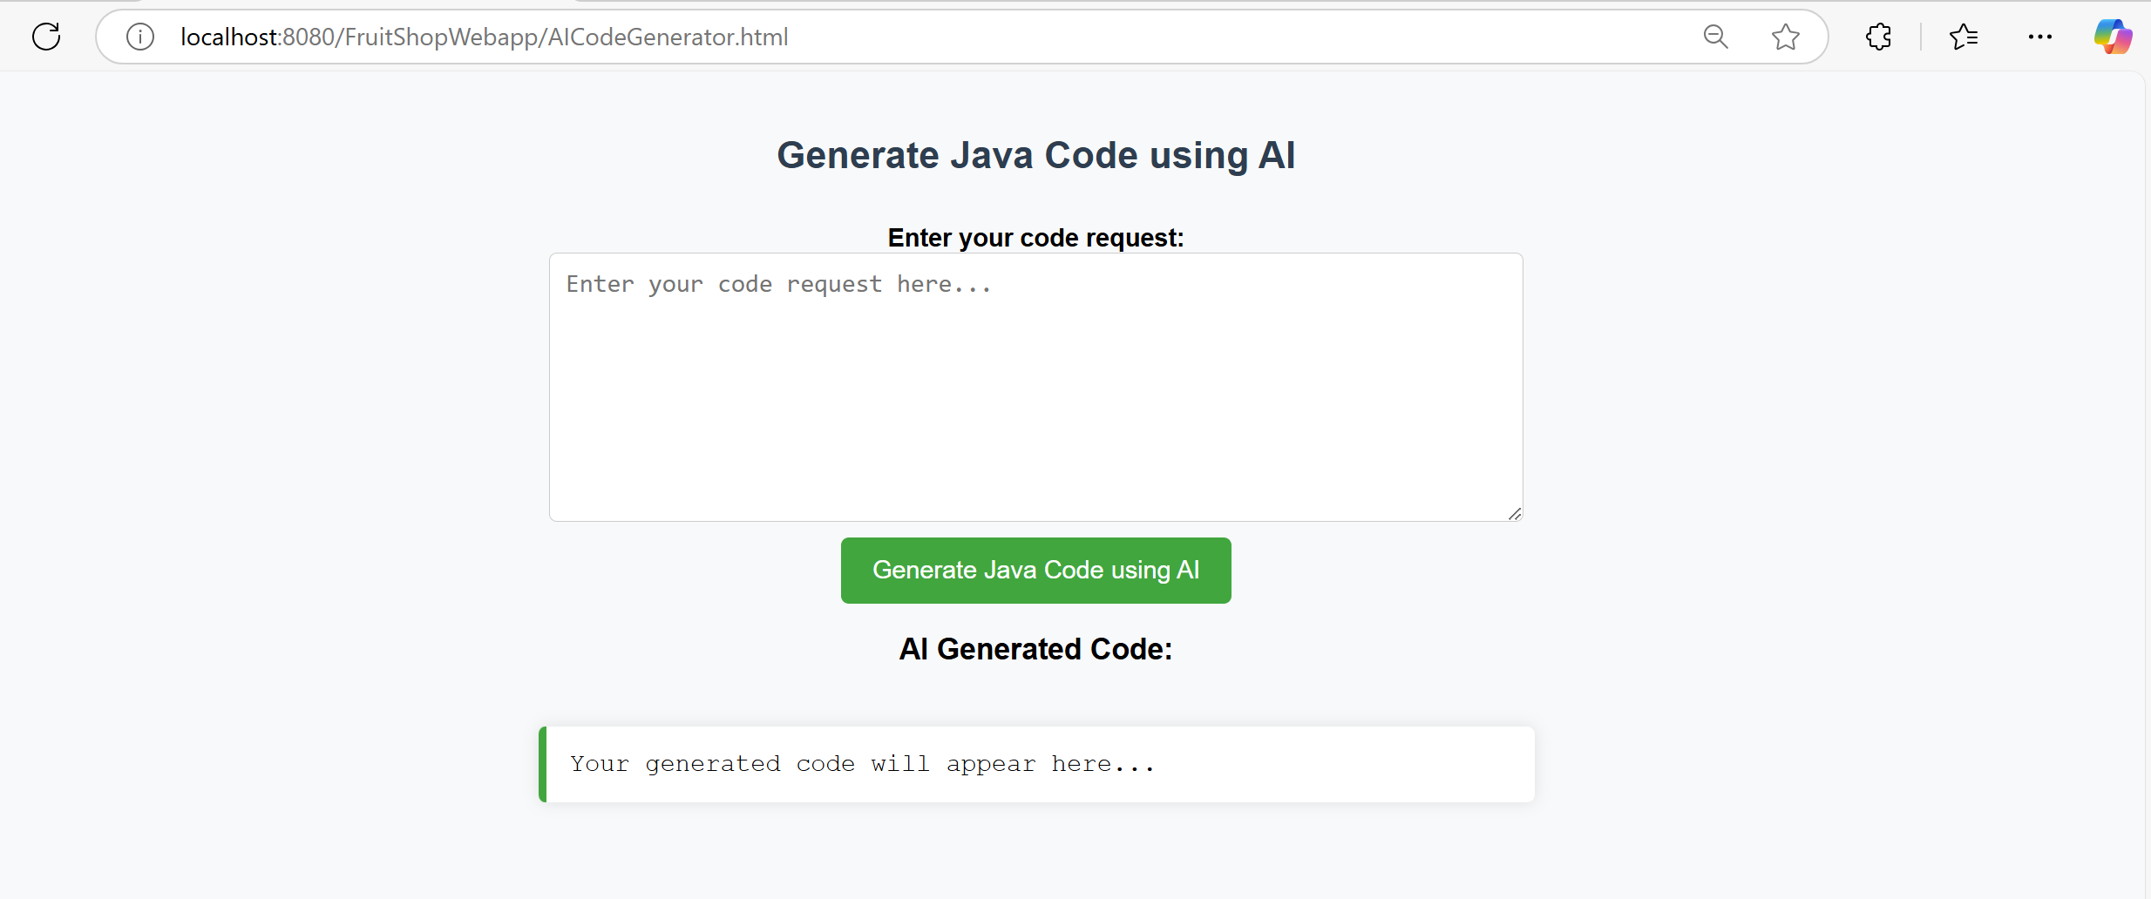
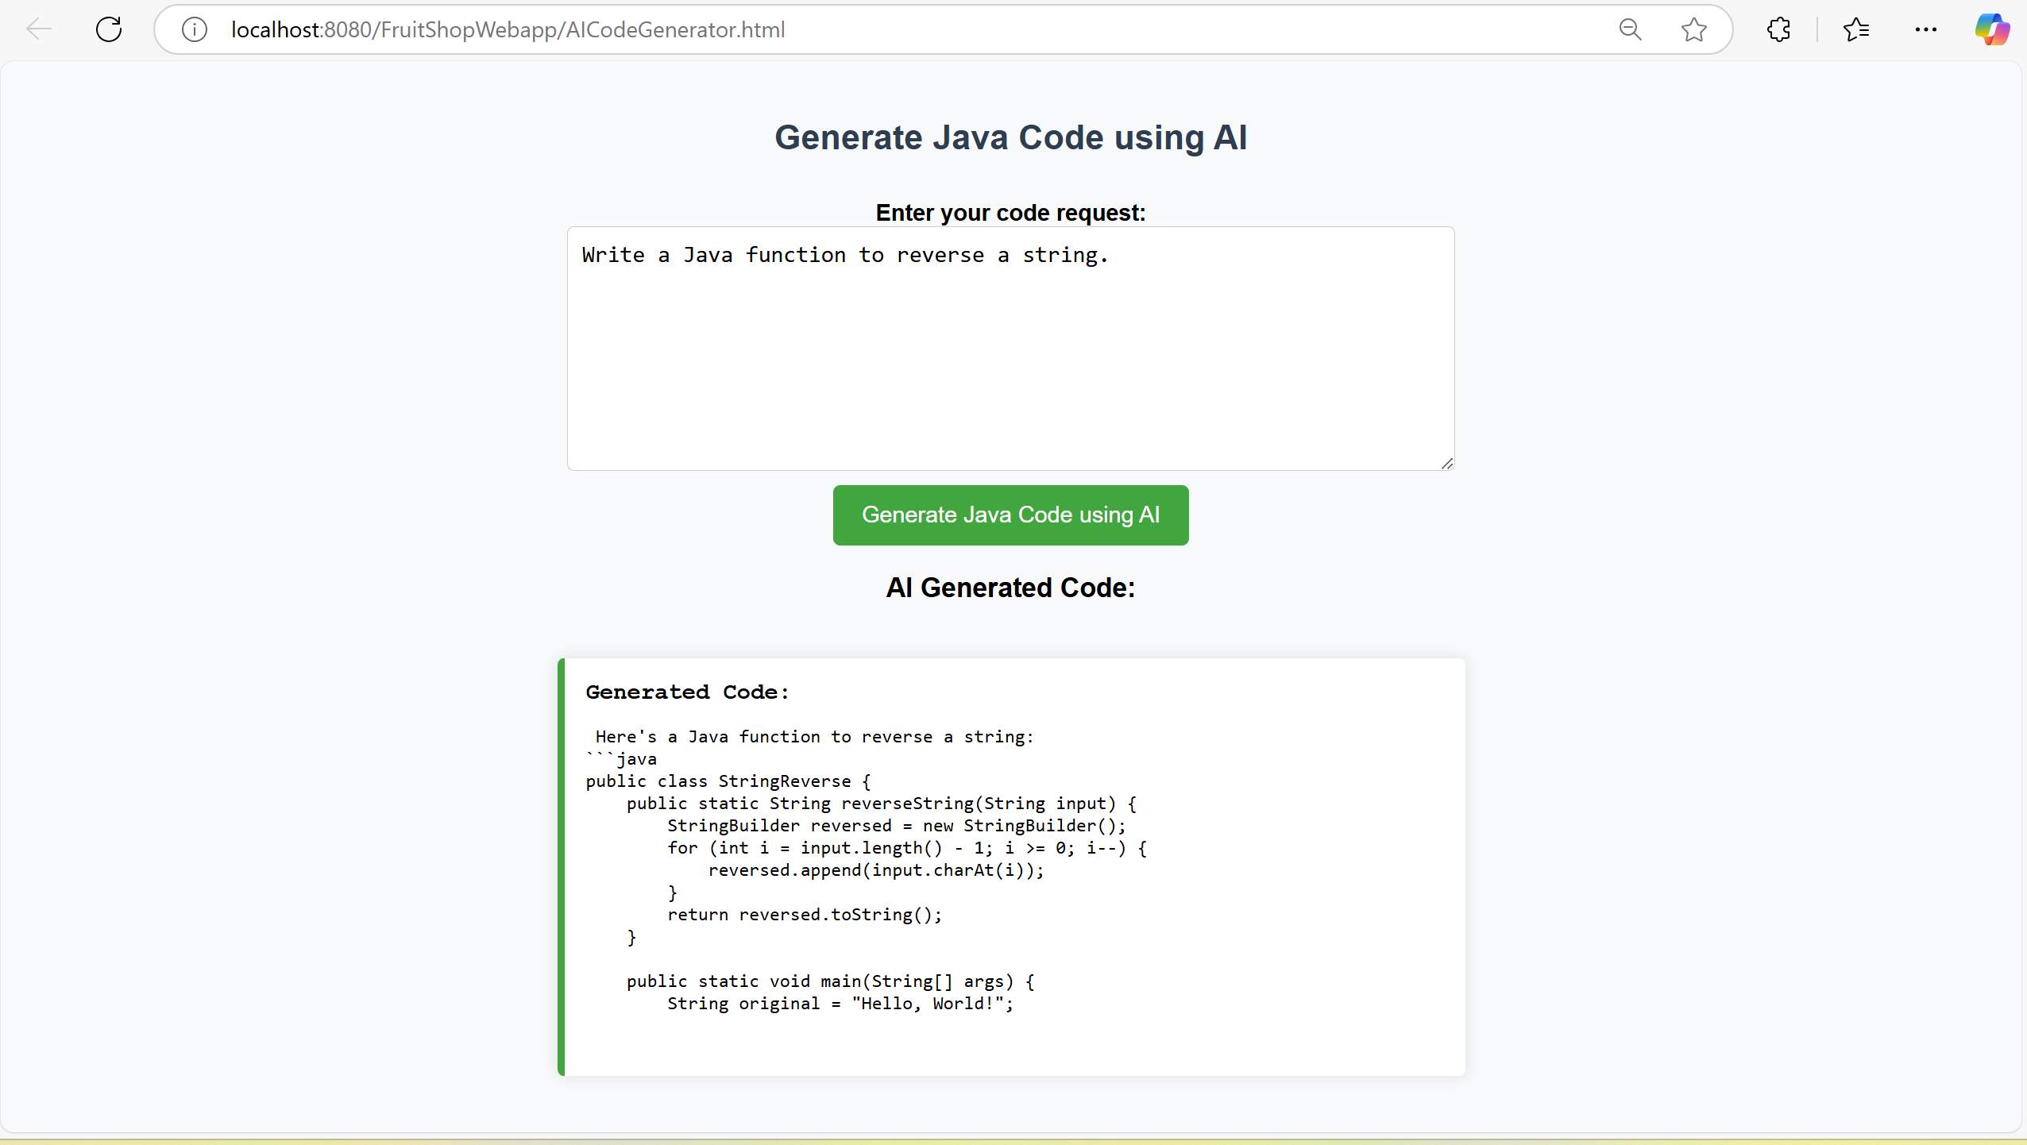

Conclusion
A Code Agent is a powerful tool that assists developers in writing, analyzing, debugging, and optimizing code using AI. By integrating it into Java Web Applications, developers can build AI-driven assistants that improve coding productivity.

